**SEMESTER 1- 2024**

**ASSIGNMENT -3**

**COS60004 – CREATING WEB APPLICATIONS**

**An analytical report on the Accessibility of the Developed Website**

**Student Name: Arun Ragavendhar Arunachalam Palaniyappan**

**Student ID : 104837257**

# 1. Executive Summary

This report assesses the accessibility of a website developed as a course assignment for the job application process of a software company, MetaPhoton Software Solutions. The evaluation adheres to WCAG 2.1, the Web Content Accessibility Guidelines, emphasizing the principles of Perceivable, Operable, Understandable, and Robust (POUR) structures. A combination of automated tools and manual examination was used for the evaluation. The findings indicate several areas where the website meets accessibility guidelines, as well as areas requiring improvement. Recommendations are provided to enhance the website's usability for all users, including those with disabilities and special needs.

# 2. Introduction

## 2.1 Website Overview

The website under examination is a job application portal built with HTML, CSS, JavaScript, PHP, and MySQL. It includes pages for job advertisements, application forms, manager logins, and company details.

## 2.2 Report Objective

The objective of this report is to assess the website's accessibility, determine its compliance with WCAG 2.1 guidelines, and make recommendations for improvements if necessary.

# 3. Analysis of the Accessibility

## 3.1 The Method of Analysis

The website's accessibility was assessed using both automated methods and personal examination, focusing on the WCAG 2.1 principles of Perceivable, Operable, Understandable, and Robust (POUR). Each principle was evaluated to determine the website's compliance and identify potential areas for improvement.

## Tools Used for Analysis

The Below Chrome Accessibility Extensions have been used:

* Lighthouse
* WAVE (Web Accessibility Evaluation Tool)

## 3.3 Detailed Accessibility Analysis

**Perceivable:**  
The core information and user interface components must be presented in a way that people can easily perceive and understand. This involves providing text alternatives for non-text content, presenting content in various ways without losing information or structure, and making content more visible and audible for all users.

* Most images on the website include alt properties providing text equivalents. However, some images on the index page lack alt tags.
* There is no time-based media on the website, avoiding the risk of outdated content.
* The website's well-designed HTML layout allows for easy adaptation to various devices and screen readers, achieved through responsive design supporting all screen sizes (mobile phones, tablets, laptops, desktops).
* The website fulfils colour contrast criteria for most parts, although certain text components have average contrast ratios that could be improved further.

**Operable:**

* The website provides a neat navigation bar at the top with links to all pages and functionalities.
* The navigation and interface components perform consistently.
* The website includes descriptive and explicit instructions and error recommendations for form validation messages, enhancing clarity for users.

**Comprehensible:**

* The website's language is English, with clear and easy-to-understand writing.
* Sans-serif fonts have been used throughout with good font sizing, ensuring readability even for users with reading difficulties.

**Robust:**

* The website is compatible with the latest user agents and assistive technologies.
* More ARIA roles could be implemented to enhance accessibility further.

# 4. Findings

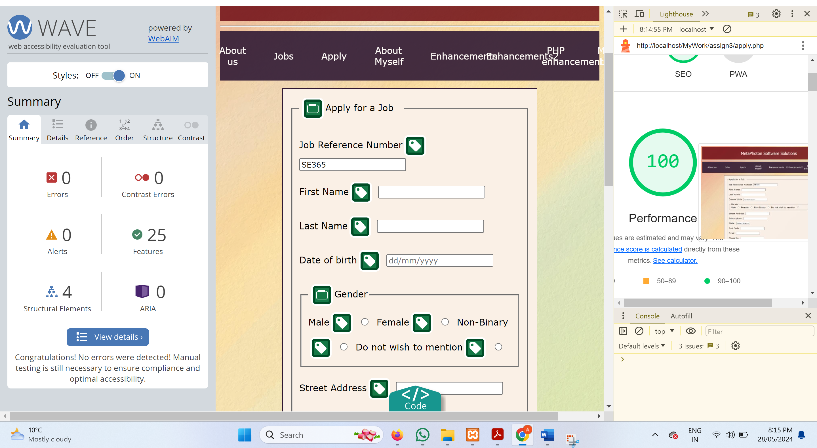**FIG 1: Accessibility analysis of the Apply Page using Wave and Lighthouse**

#### WAVE Accessibility Evaluation (Job Application Form)

* Errors: 0
* Contrast Errors: 0
* Alerts: 0
* Features: 25
* Structural Elements: 4
* ARIA: 0

#### Lighthouse Performance Metrics (Job Application Form)

* SEO: 100
* Performance: 100

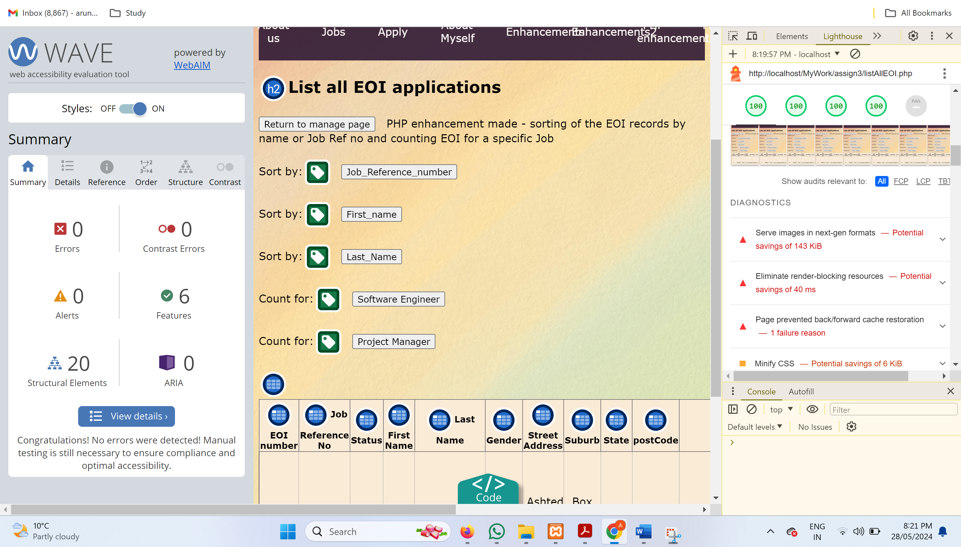

**FIG 2: Accessibility and performance analysis of the Manager Page using Wave and Lighthouse**

#### WAVE Accessibility Evaluation (Manager Page)

* Errors: 0
* Contrast Errors: 0
* Alerts: 0
* Features: 6
* Structural Elements: 20
* ARIA: 0

#### Lighthouse Performance Metrics (Manager Page)

* Performance: 100
* Accessibility: 100
* Best Practices: 100
* SEO: 100

**Detailed Lighthouse Diagnostics for the whole Application**

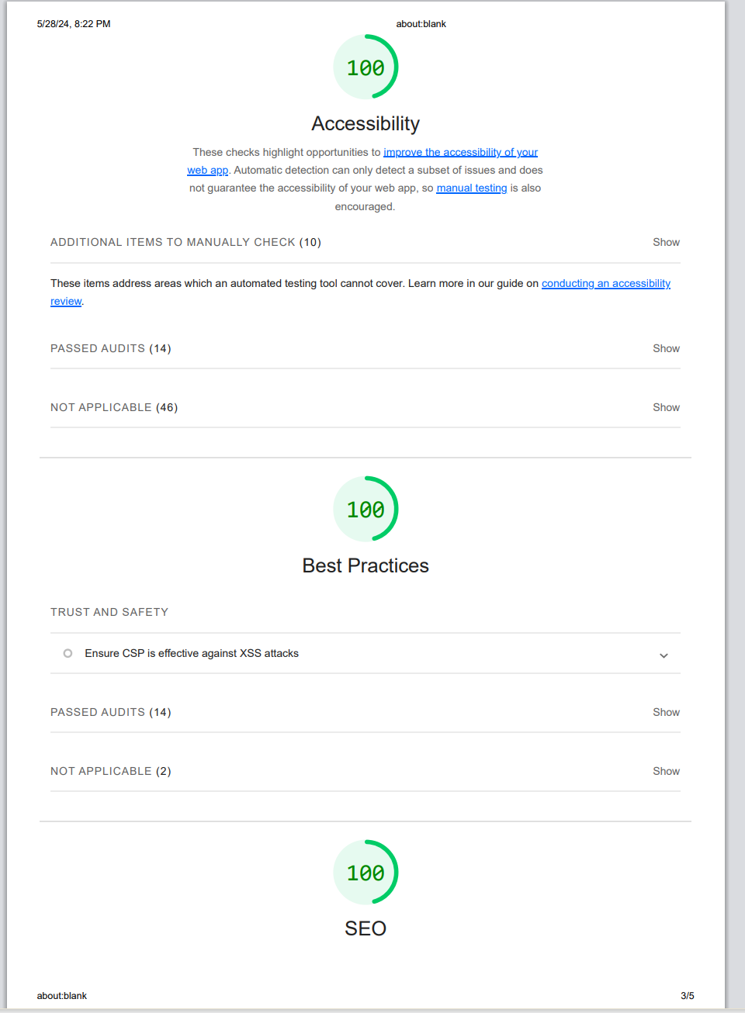

**Fig 3: Accessibility report of the website from Lighthouse Tool**

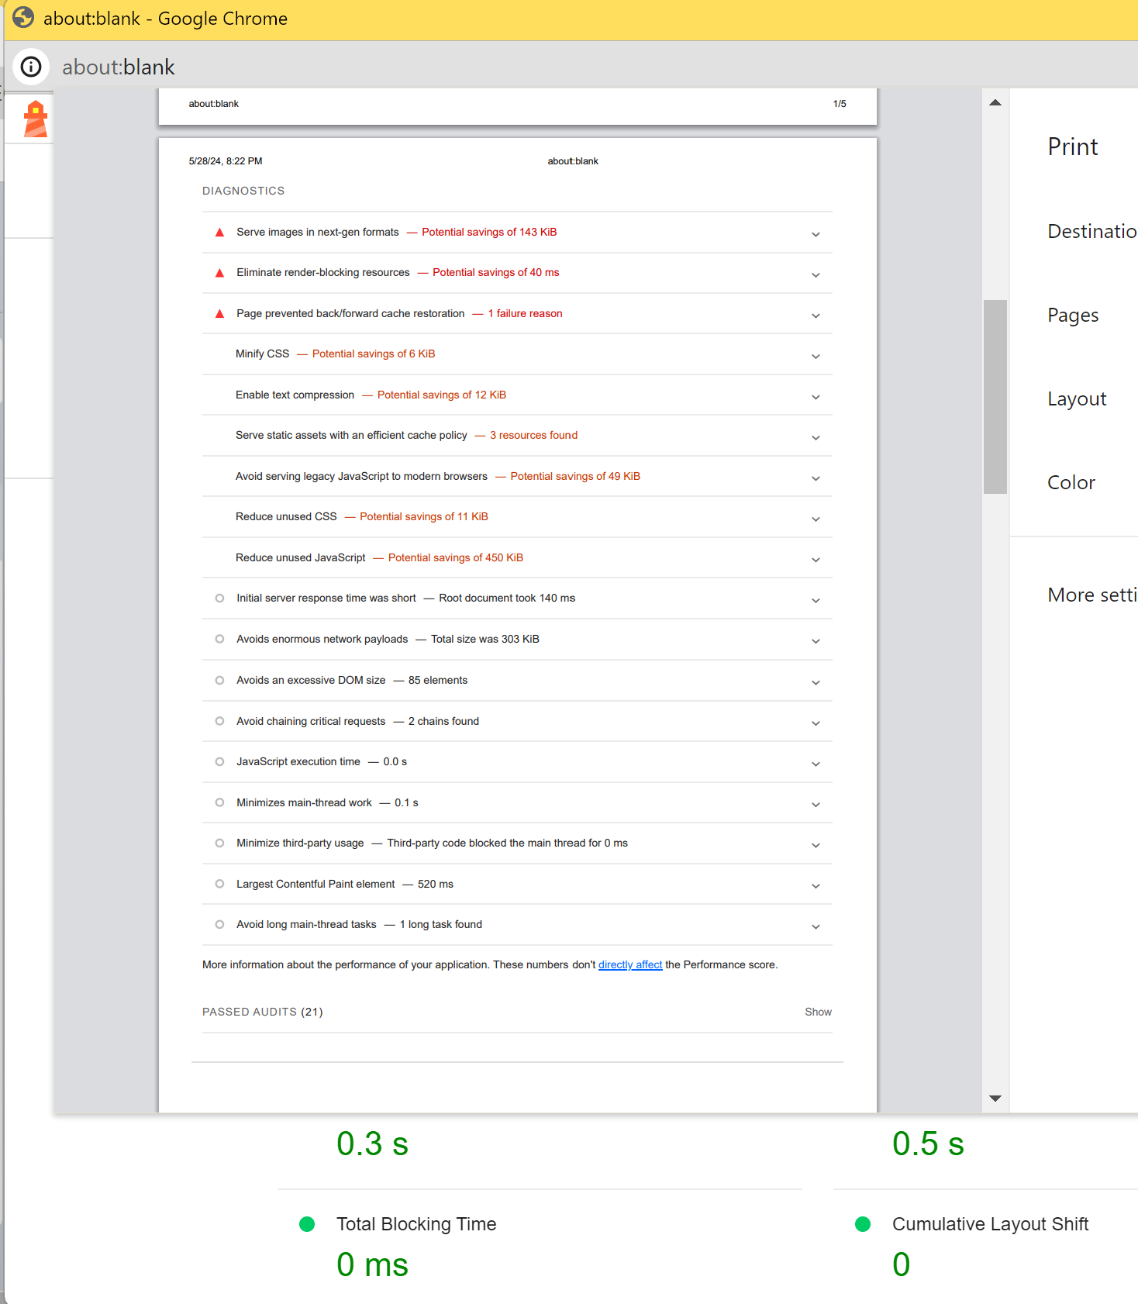

**Fig 4: Diagnostic report From Lighthouse Tool**

* **Eliminate render-blocking resources:** Potential savings of 40 ms
* **Page prevented back/forward cache restoration:** 1 failure reason
* **Minify CSS:** Potential savings of 6 KiB
* **Enable text compression:** Potential savings of 12 KiB
* **Reduce unused CSS:** Potential savings of 11 KiB
* **Initial server response time was short:** Root document took 140 ms
* **Avoids enormous network payloads:** Total size was 303 KiB
* **Avoids an excessive DOM size:** 85 elements
* **JavaScript execution time:** 0.0 s
* **Minimizes main-thread work:** 0.1 s
* **Largest Contentful Paint element:** 520 ms
* **Avoid long main-thread tasks:** 1 long task found

# 5. Discussion

The findings from the WAVE and Lighthouse evaluations highlight that the website demonstrates a high level of compliance with WCAG 2.1 accessibility standards. **There are no major errors or no major accessibility issues**, and the structural elements are sound. This indicates a **strong foundation in terms of accessibility.**

However, the detailed Lighthouse diagnostics suggest several areas for potential optimization to improve performance and usability further. For instance, serving images in next-gen formats, eliminating render-blocking resources, and minifying CSS and JavaScript can significantly enhance the website's loading speed and efficiency. Additionally, implementing text compression and efficient caching policies will help reduce network payloads and improve overall user experience.

The specific recommendations for improvement include increasing the use of ARIA roles to enhance compatibility with assistive technologies, ensuring all images have appropriate alt text, improving text colour contrast for better readability, and ensuring all form elements are fully keyboard accessible. Furthermore, providing more detailed instructions and validation messages for form inputs will enhance user understanding and ease of use.

# 6. Conclusion

## 6.1 Summary of Findings

The job application website demonstrates a strong commitment to accessibility, with many elements meeting WCAG 2.1 standards. However, to ensure complete compliance and improve usability for all users, including those with disabilities, certain areas need attention.

## 6.2 Recommendations for Further Improvement

* **Robustness:** Compatibility with assistive technology should be increased by incorporating additional ARIA roles.
* **Perceivable:** Alt text should be included for all images, including decorative ones. Text element colour contrast could be improved.
* **Operable:** All form elements could be made keyboard accessible.
* **Understandable:** More detailed instructions and messages for form validation could be provided.

# 7. References

* W3C (World Wide Web Consortium). (n.d.). Web Content Accessibility Guidelines (WCAG) 2.1. Available at: <https://www.w3.org/TR/WCAG21/> (Accessed: [date]).
* WebAIM. (n.d.). Web Accessibility In Mind. Available at: <http://webaim.org/articles/> (Accessed: [date]).
* University of Michigan. (n.d.). Web Accessibility. Available at: <http://hr.umich.edu/webaccess/> (Accessed: [date]).
* Penn State. (n.d.). Accessibility. Available at: <http://accessibility.psu.edu/tutorial> (Accessed: [date]).

# 8. Appendix

**Tools Used for Analysis:**

* Chrome Extensions: WAVE, Lighthouse

**Figures and captions:**

**Figure 1: Accessibility analysis of the Apply Page using Wave and Lighthouse**

**Figure 2: Accessibility and performance analysis of the Manager Page using Wave and Lighthouse**

**Figure 3: Accessibility report of the website from Lighthouse Tool**

**Figure4:** Diagnostic report From Lighthouse Tool